**Software Design Document**

**for**

**Trader Evaluation System 1.0**

**Version 0.4**

**Prepared by <Mengyao Wang, Teng Tang, Ashish Tripathi, Josiah Tolento>**

**<INFO 3150 – Object Oriented Software Engineering>**

**<Mar 25, 2019>**

**Table of Contents**

1.0 INTRODUCTION 3

1.1 Purpose 3

1.2 Scope 3

1.3 Overview 3

1.4 Reference Material 3

1.5 Definitions and Acronyms 3

2. SYSTEM OVERVIEW 4

2.1 Classes and Types: 4

2.2 Contents: 4

2.3 Relationships: 4

3.0 SYSTEM ARCHITECTURE 5

3.1 Architectural Design 5

3.2 Decomposition Description 6

3.3 Design Rationale 6

4.0 DATA DESIGN 6

4.1 Data Description 6

5.0 HUMAN INTERFACE DESIGN 7

5.1 Overview of User Interface 7

5.2 UI Wireframes 7

5.3 Screen Objects and Actions 12

**Revision History**

|  |  |  |  |
| --- | --- | --- | --- |
| **Name** | **Date** | **Reason For Changes** | **Version** |
| Ashish Tripathi, Josiah Tolento | 02/16/2019 | Initial draft. | 0.1 |
| Mengyao Wang | 02/19/2019 | Second draft | 0.2 |
| Teng Tang | 02/20/2019 | Added component diagram | 0.3 |
| Teng Tang,  Mengyao Wang | 03/25/2019 | Added description and UI design for new requirements | 0.4 |

## 1.0 INTRODUCTION

The project is to create a web-based system that stores and evaluates trader employees’ records for a stock trading company. It also stores historic stock information.

This design document presents the designs used or intended to be used in implementing the project. The designs described, follow the requirements specified in the SRS document prepared for the project.

### 1.1 Purpose

The purpose of this document is to present a detailed description of the trading system that stores stock historic information and employee trading information (including date and time, stock names and shares) that can be used to evaluate each trader’s performance (by calculating their monthly and yearly winning rate).

### 1.2 Scope

The document gives a detailed description of the software architecture of the trading evaluation system. It specifies the structure and design of some of the modules discussed in the SRS.

### 1.3 Overview

This document will consist of 5 sections. The first is the overview of the document, the second goes over the classes and their relationships of the system, the third describes the architecture of the system, the fourth describes the data design, and the last shows the user interface of the system.

### 1.4 Reference Material

https://www.google.com/url?sa=t&rct=j&q=&esrc=s&source=web&cd=1&cad=rja&uact=8&ved=2ahUKEwjErIm5p8zgAhUsFjQIHW3FDckQFjAAegQIBxAB&url=https%3A%2F%2Fieeexplore.ieee.org%2Fdocument%2F741934%2F&usg=AOvVaw2EKCLC2JxWawpJW3qxMzr6

### 1.5 Definitions and Acronyms

|  |  |
| --- | --- |
| Term | Definition |
| SRS | Software Requirement Specification document |
| User | Employees of the company that uses the system. |
| Trader Employee | Employees of the company that trade stock on behalf of the company. |
| HR Employee | Employees of the Human Resource department |

## 2. SYSTEM OVERVIEW

The system has a web user interface and a database. Users interact with the system through web browsers, data are imported and stored into the database.

### 2.1 Classes and Types:

The Employee class is the class that holds employee information of the company, it has five sub-classes: TraderEmployee, HREmployee, FinanceDep, AnalysisTeam and Administrator.

TraderEmployee class is the class for trader employees.

HREmployee class is the class for HR employees.

FinanceDep class is the class for Finance Department employees.

AnalysisTeam class is the class for Analysis Team employees.

Administrator class is the class for system administrators.

Account is the class used for login to the website.

TraderEmployeeAccount class is for trader employees, it allows its users to upload and view its own trading record.

HREmployeeAccount class is for HR employees to view all trading records and perform calculation on those records.

FinanceDepAccount class is for Fianance Department employees to view trading records and perform calculation (generating financial report and calculate commission) on them.

AnalysisTeamAccount class is for Analysis Team employees to view stock records for analysis purpose.

AdministratorAccount class is for administrators to manage other accounts of the system.

Trading Record is the class which holds information about the stock trading transactions.

Stock is the class holds stock information.

### 2.2 Contents:

Employees contain information of the employees in the company including ids, names and positions.

Accounts contain information regarding the trading records and the ids assigned to them for each individual trader.

Trading Records lists all the transactions done by the trader, the date they were performed, and who they were performed with.

Stock contains historic information of a stock, including the date, open/close price, highest/lowest price and volume.

### 2.3 Relationships:

Class relationships are shown in the diagram below.

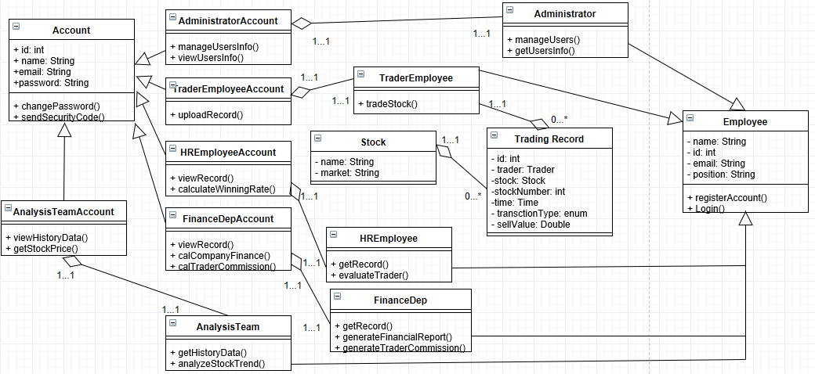

## 3.0 SYSTEM ARCHITECTURE

### 3.1 Architectural Design

The system has a web interface and a database, as shown in the diagram.

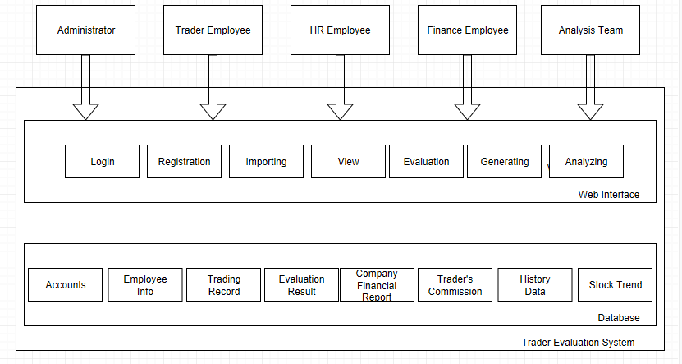

### 3.2 Decomposition Description

Users interact with the web interface of the system, the web interface contains web pages for login, registration, importing trading record, viewing record and displaying calculation result. The back end of the website connects to a database which contains tables for user accounts, employee information, trading records , stock information and evaluation results.

### 3.3 Design Rationale

Web-based interface is easy to use and can support different platforms. Database is used to store the data permanently.

## 4.0 DATA DESIGN

### 4.1 Data Description

Account: user account for employees of the company, it contains account name, id, password, employee id and privilege level.

Employee Info: data that contains the company’s employees’ information, including id, name, position, contact and address.

Trading Record: data generated by compatible trading tracking system, it contains id and trading data: time, stock name, the price to buy and sell, number of shares, the gross, the fee, and the net of each trade.

Stock Info: history data of a stock, includes date, open price, close price, highest price, lowest price and volume.

Evaluation Result: winning rate calculation result for each trader, includes evaluation id, employee id, winning rate and calculation period.

Financial Report: monthly and yearly financial report of the company generated based on the trading records.

Trader’s Commission: trader’s commission calculated based on his monthly earnings.

## 5.0 HUMAN INTERFACE DESIGN

### 5.1 Overview of User Interface

Users will be able to either login with their account username and password or register a new account, taking the credentials of first and last name, user name, password, email, and company information.

The traders screen will detail the recent transactions of the user, including the date and time of the trade, stock name, buying and selling price, number of shares, the gross, the fee, and the net of the trade.

Human Resources users with the appropriate credentials will be able to go through a users transaction history and the calculation screen will calculate and display the users monthly and yearly winnings.

Financial Department users can view the records and let the system generate a report based on monthly or yearly transactions. They can also let the system calculate the commissions of traders, based on their monthly earnings.

Analysis Team users can view the historic data of stocks for analysis purpose.

### 5.2 UI Wireframes

5.2.1 Index Page

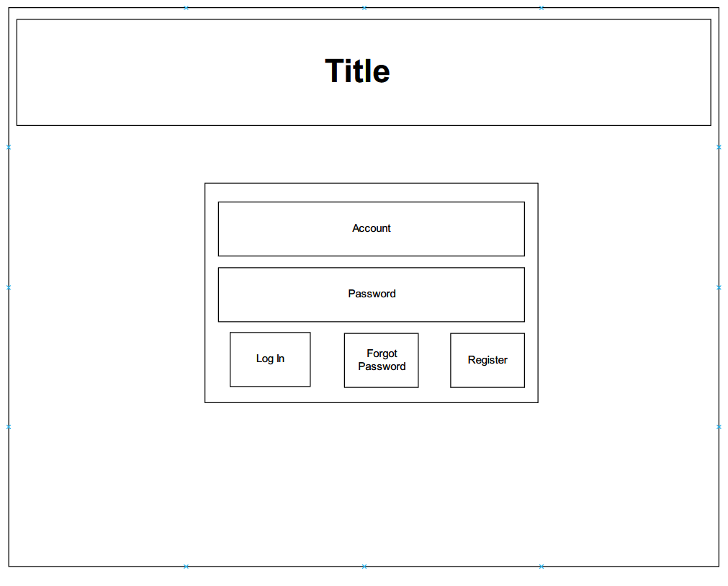

5.2.2 Registration Page

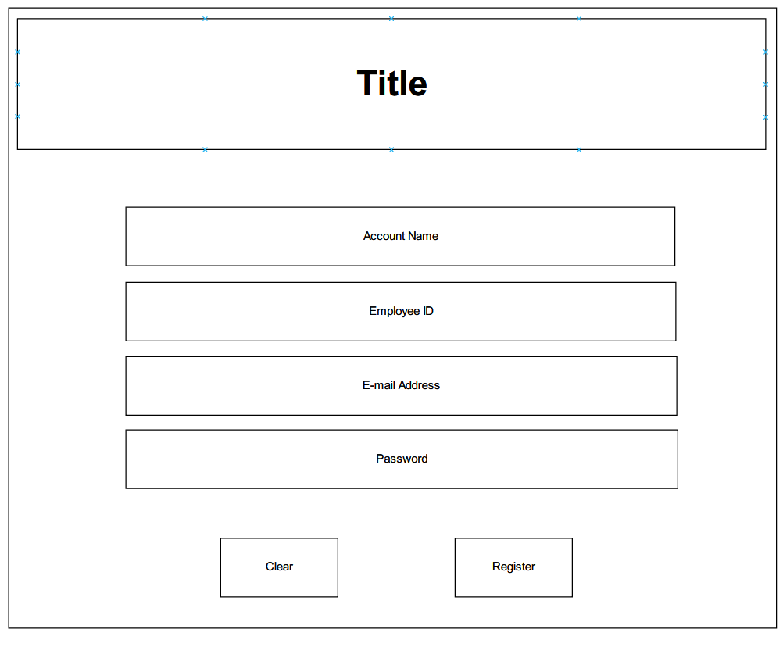

5.2.3 Forgot Password Page

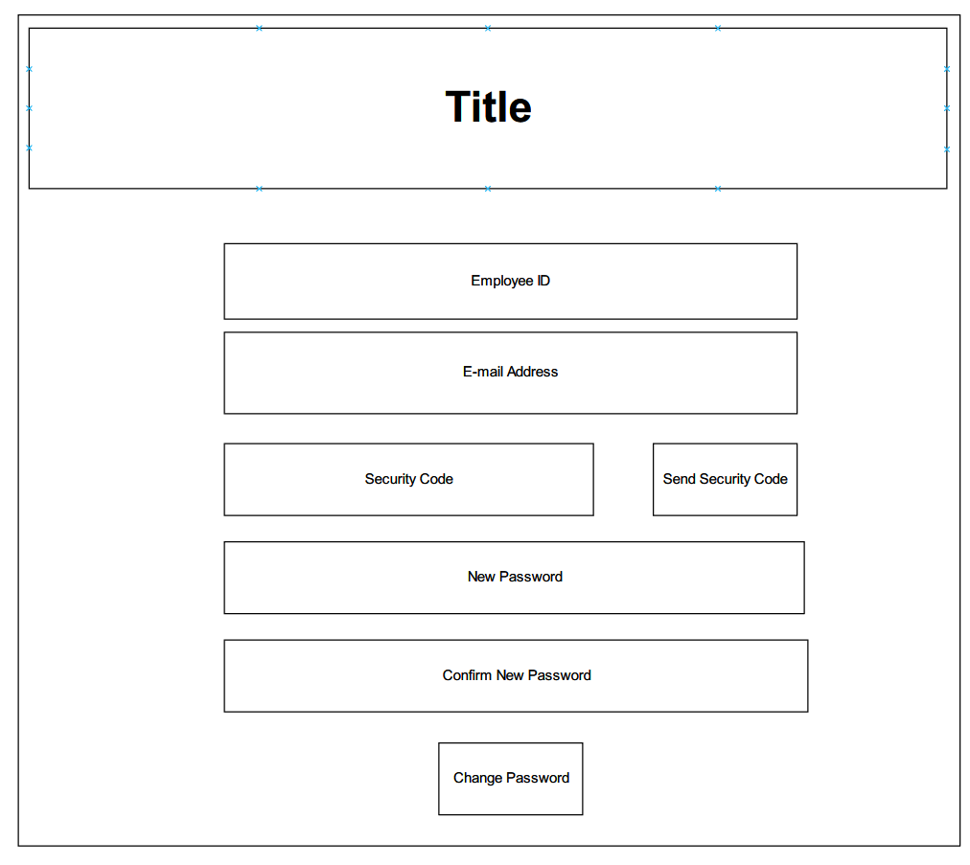

5.2.4 Change Password Page

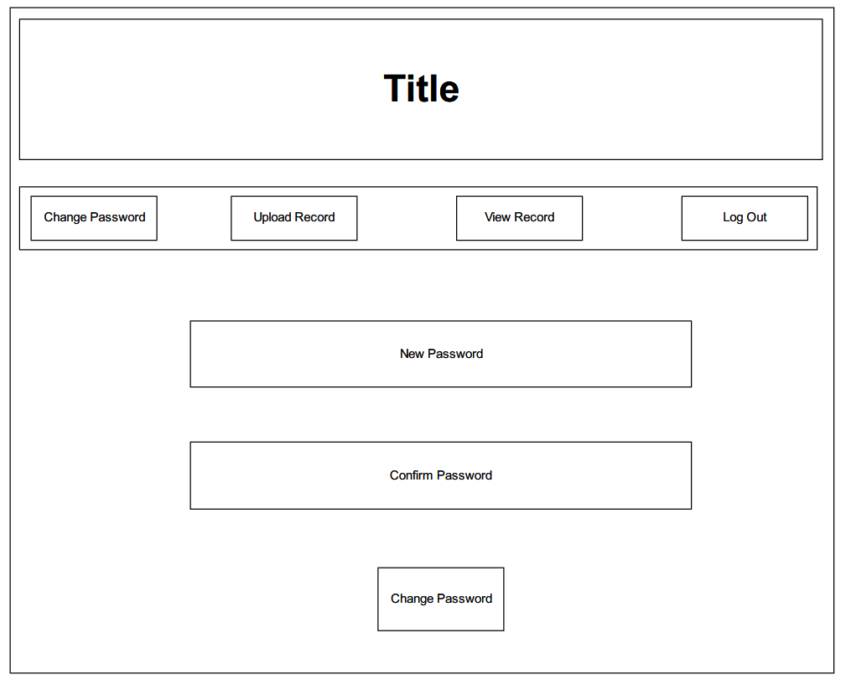

5.2.5 Upload Record Page for trader accounts

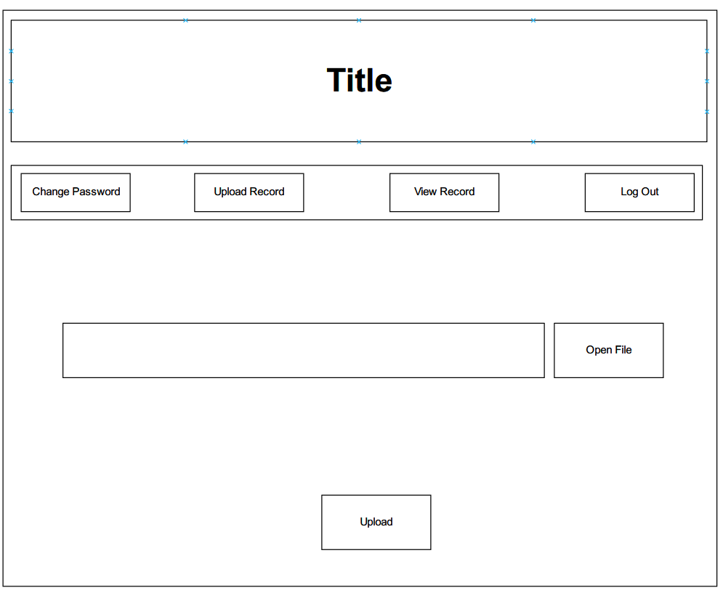

5.2.6 View Record Page for trader accounts

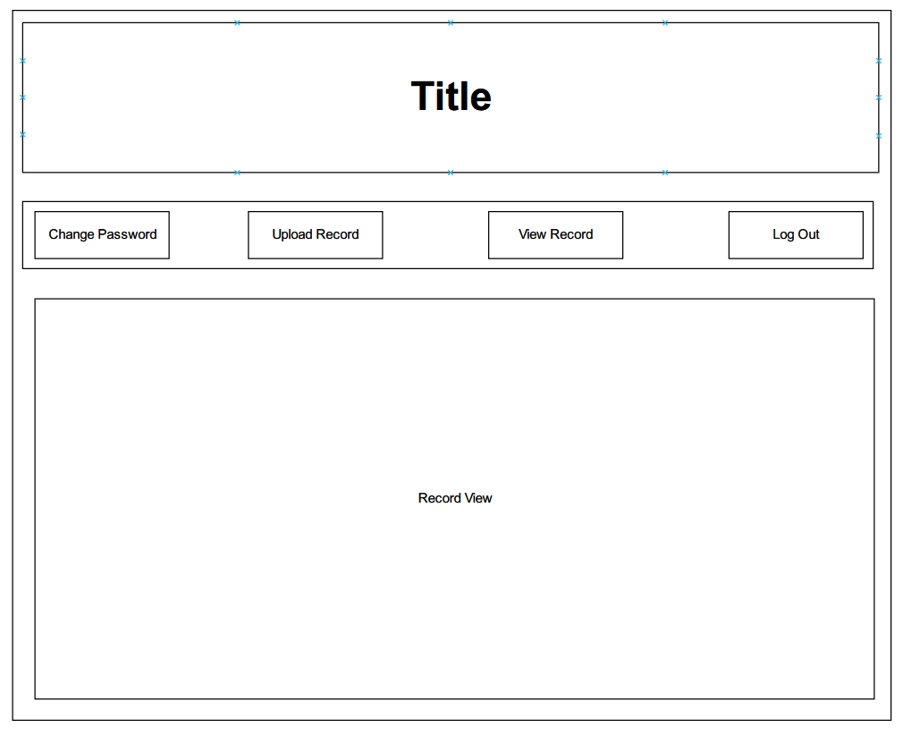

5.2.7 View Records Page for HR accounts 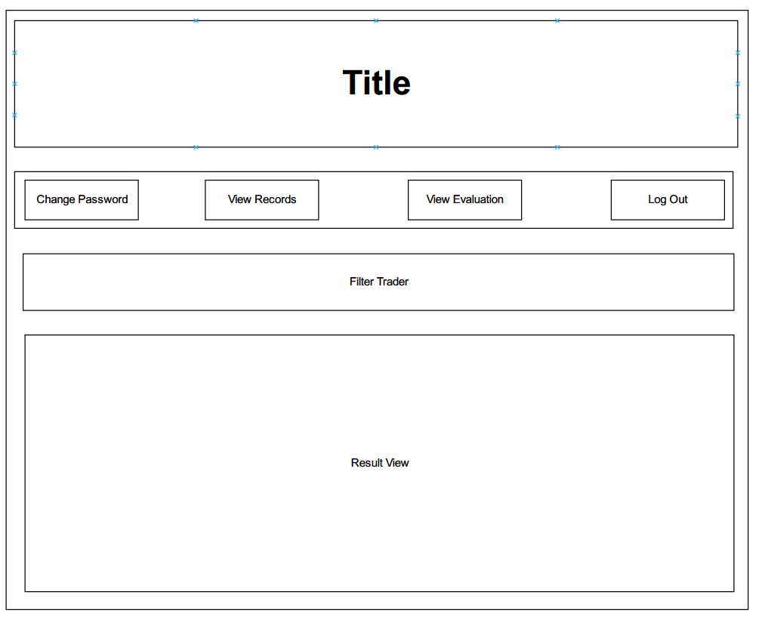

5.2.8 View Result Page for HR accounts

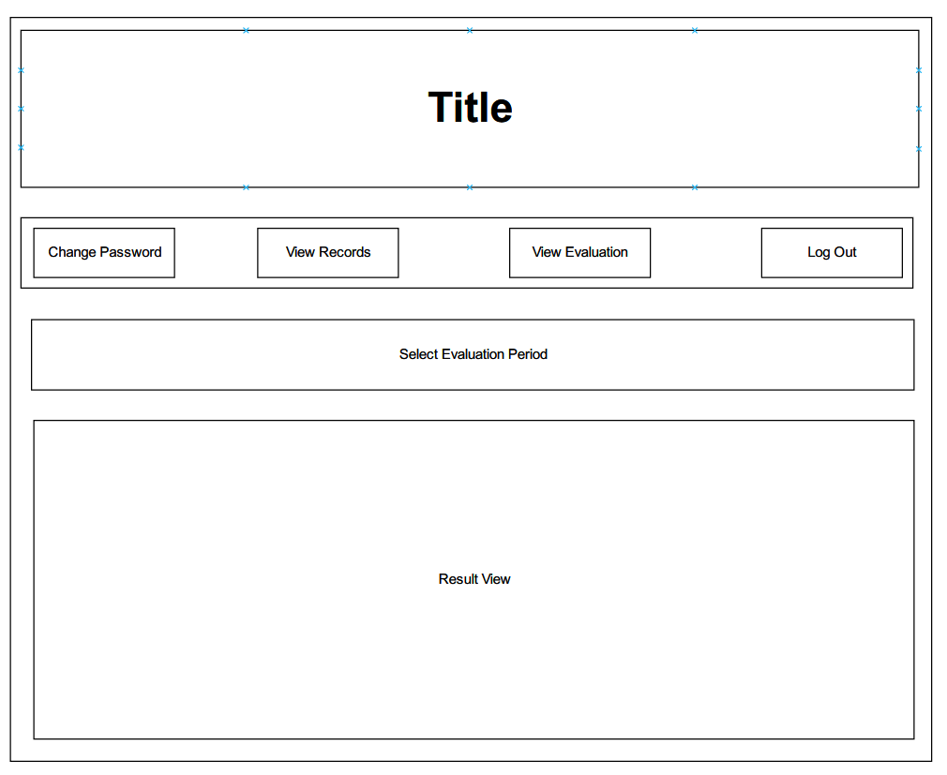

5.2.9 Finance Report page for Finance Department accounts

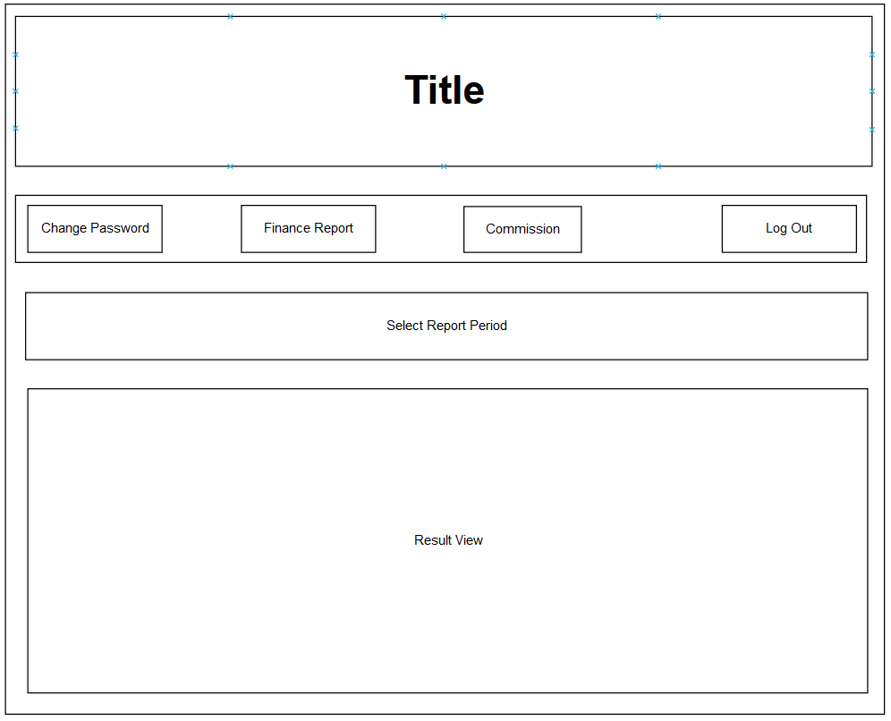

5.2.10 Commission page for Finance Department accounts

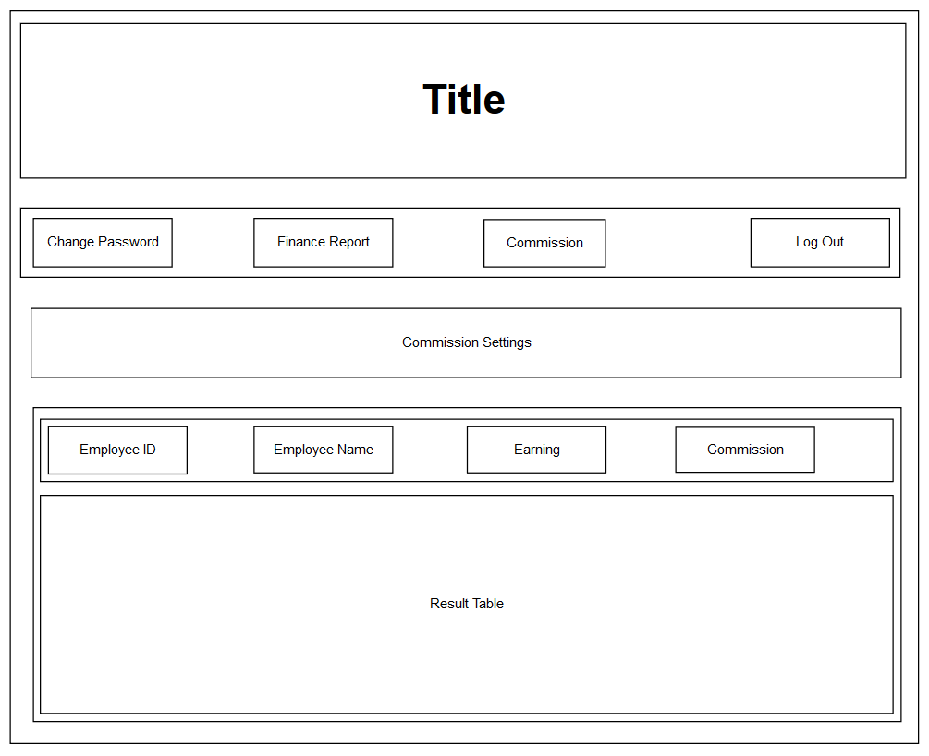

5.2.11 Stock information page for Analysis Team accounts

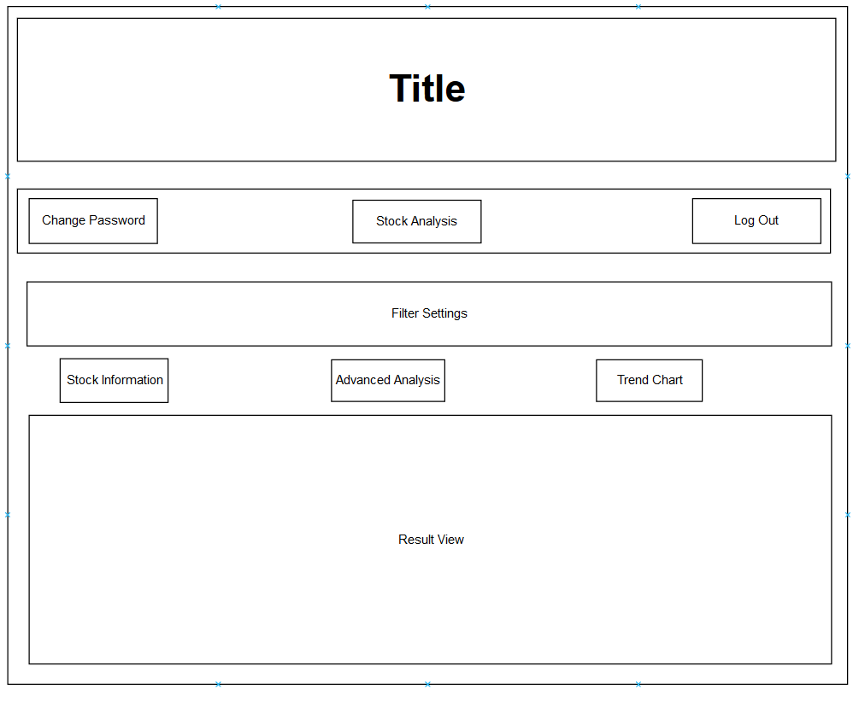

5.2.12 Account Management page for administrator accounts

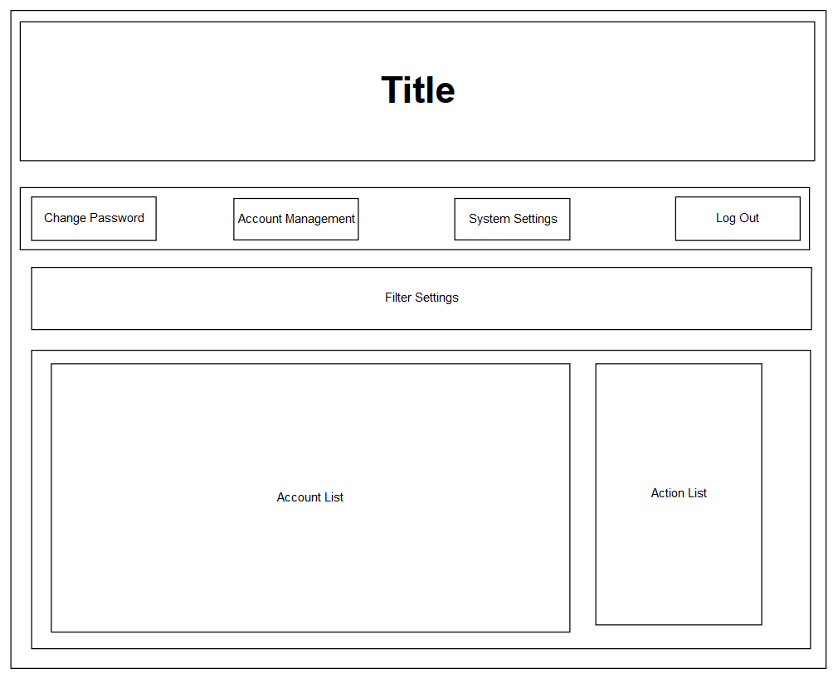

5.2.13 System Settings page for administrator accounts

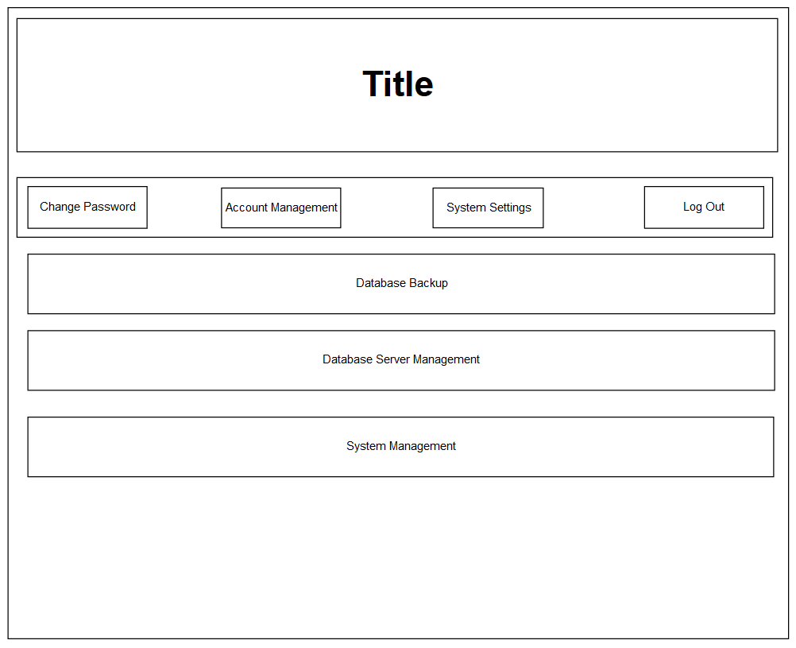

### 5.3 Screen Objects and Actions

Username and password credentials are cross referenced with the information in the database and will have access to the application or denied upon clicking the login button.

Registration button will bring users to a registration page where they need to fill in the appropriate text boxes and registered.

Forgot Password button will bring users to a page that can change the password with a security code which is sent to the user’s e-mail address.

Change Password page allows user to directly change the account password when logged in.

Upload Records page allows user to upload a file containing trading records. Open File button directs to the file and Upload button uploads the file to the database.

View Record page for trader users allow them to view their own trading records.

View Records page for HR users allow them to view all traders’ trading records, the Filter Trader button allows HR users to view selected traders’ records.

View Evaluation page allows HR users to view the traders’ winning rate, the Select Evaluation Period button filters the period of evaluation.

Finance Report page allows Finance Department users to generate and view finance report of a given period.

Commission page allows Finance Department users to generate and view commission of trader employees, based on their earnings.

Stock Information page allows Analysis team to view detailed stock information.

Account Management page allows administrator to manage all user accounts.

System Settings page allows administrator to manage the system and the database.